DATABASE ACCESSING BY USING PYTHON
Q1: id present in ent_client but not in alert_configs
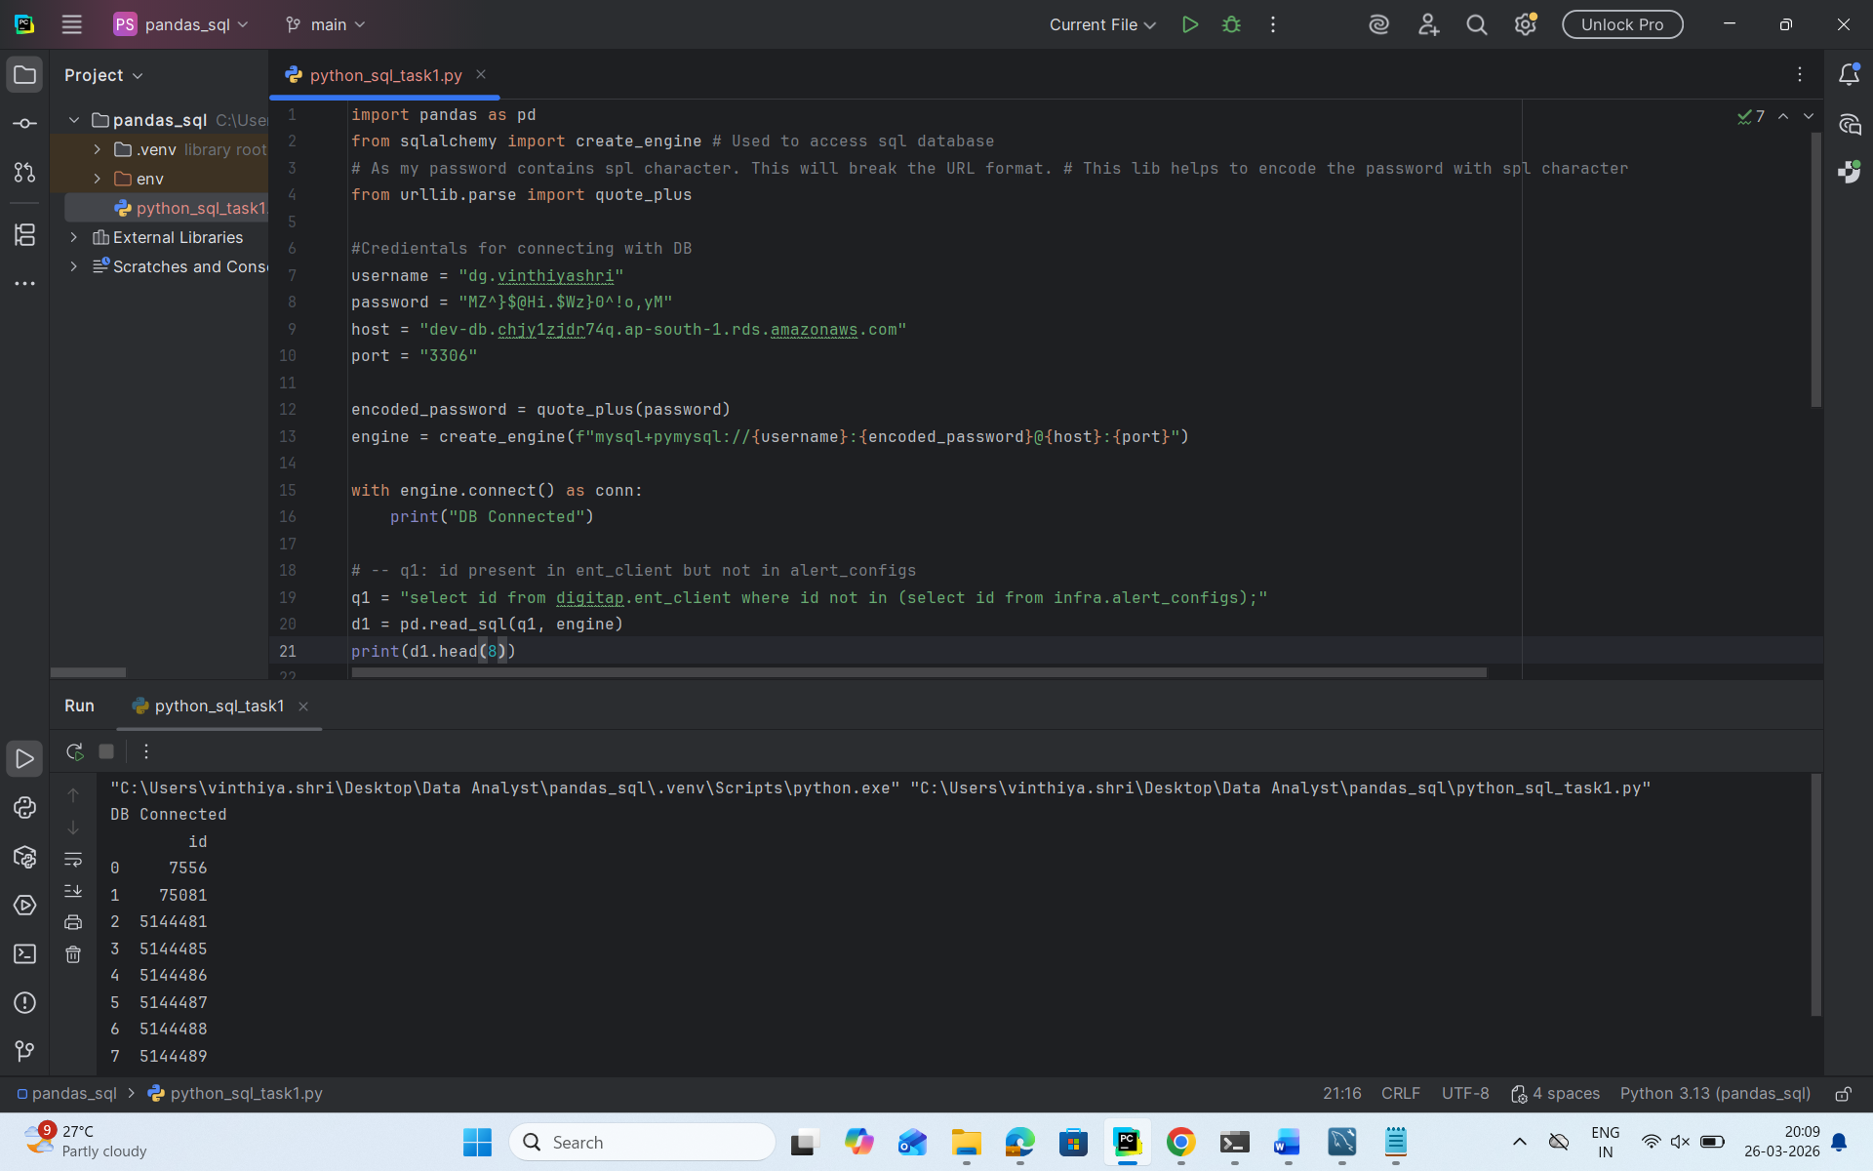

Q2: id present in ent_client but not in monitoring_service_configs
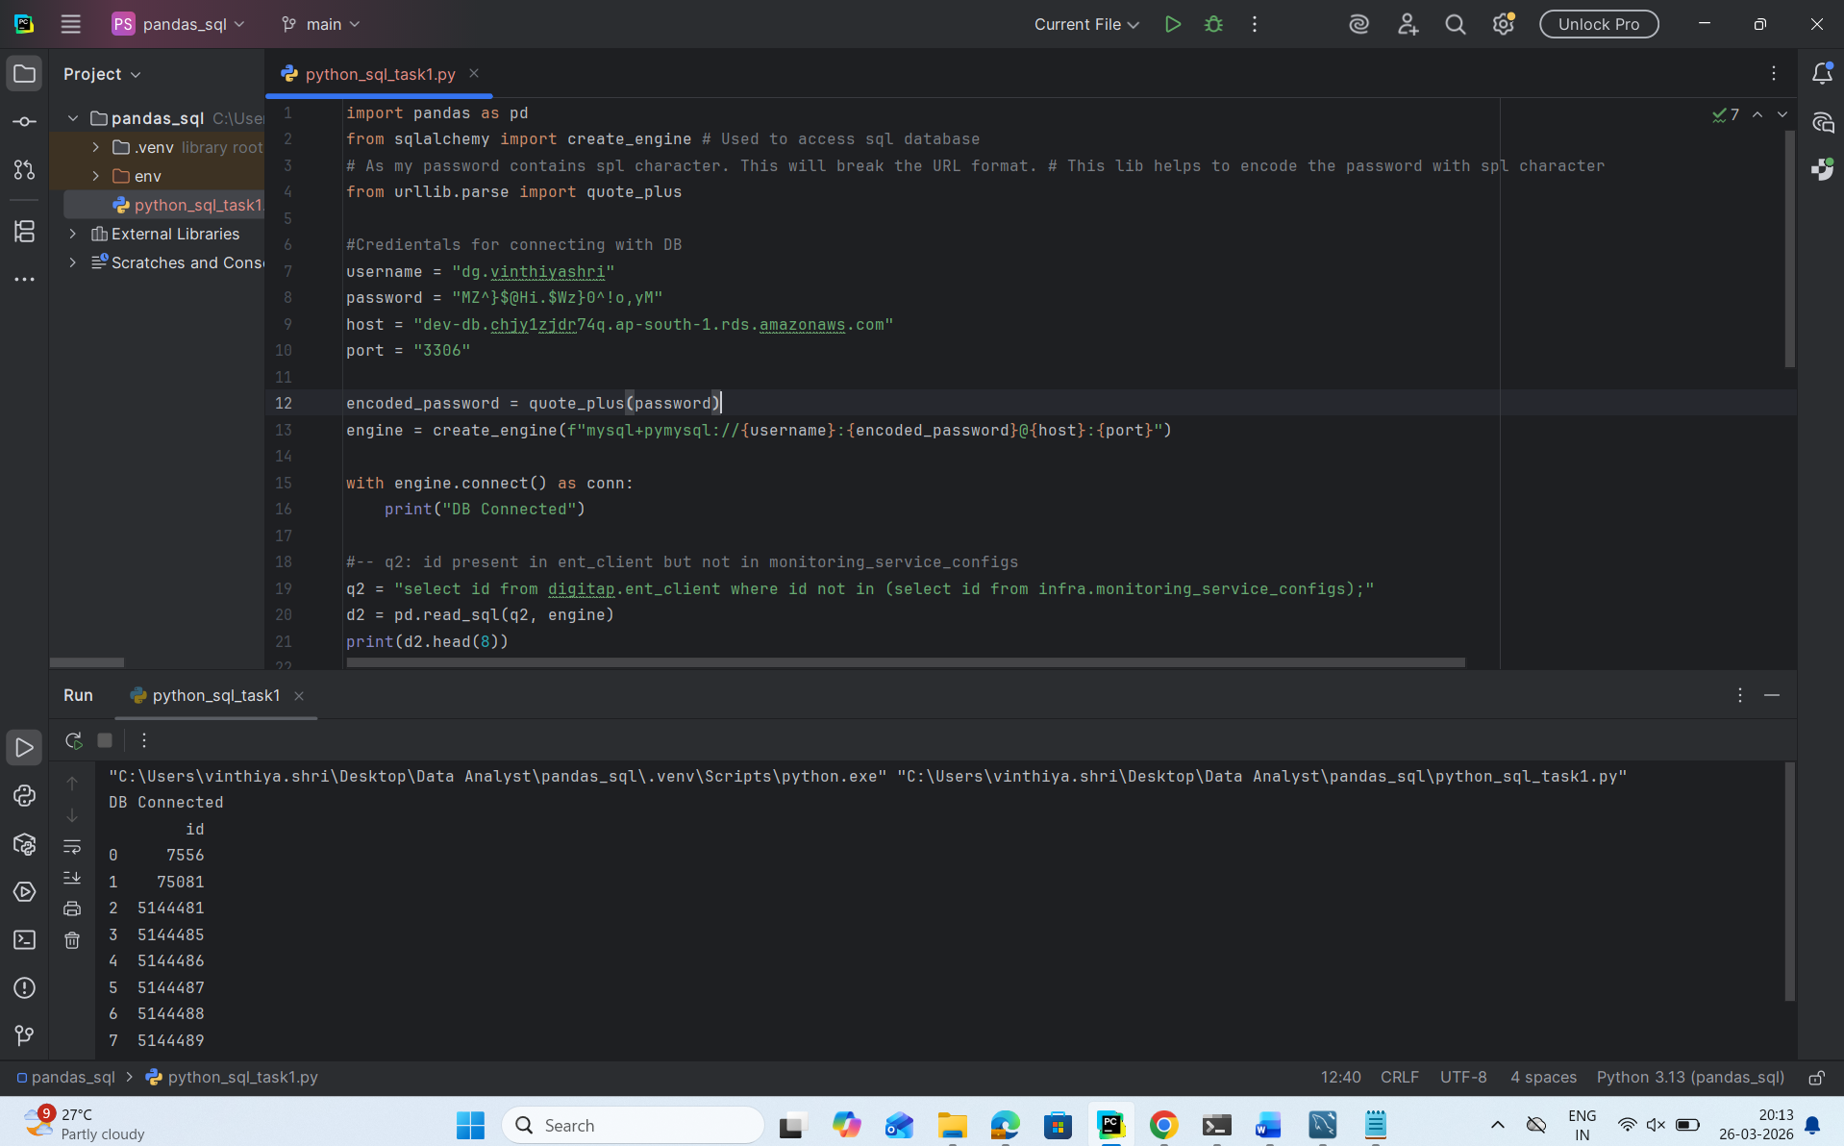

-- Q3: id present in ent_client & present in monitoring_service_configs but not in alert_configs
